Task 4.1P — Software Testing Submission
Student Name: Ayush Indapure
Student ID: 224880003

This task was about understanding and testing a login system using decision tables and JUnit test cases. It involved analysing different combinations of inputs like username, password, and validation code. Based on that, we created multiple test cases to verify if the system behaves correctly in all scenarios.
Screenshot of JUnit tab which shows test statistics including Runs, Errors and Failures
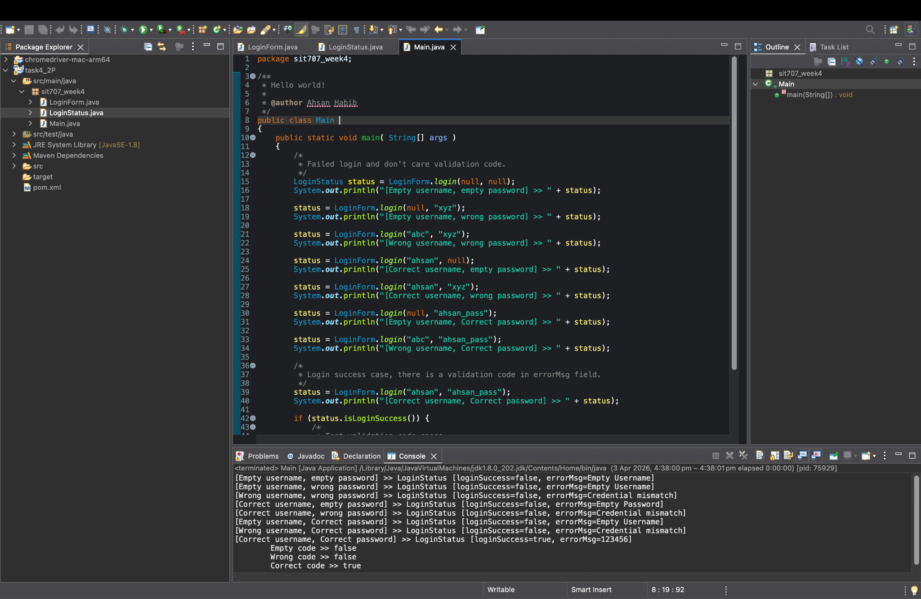

Screenshot of eclipse console which shows the output
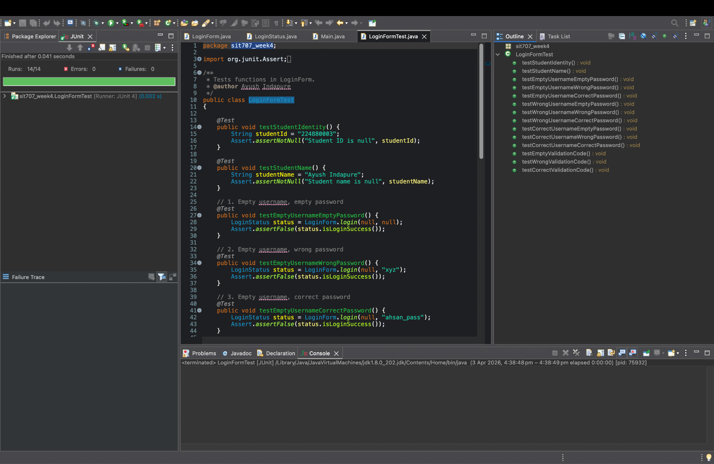

My programs source code for tests (LoginFormTest.java)
package sit707_week4;

import org.junit.Assert;
import org.junit.Test;

/**
* Tests functions in LoginForm.
* @author Ayush Indapure
*/
public class LoginFormTest
{

@Test
public void testStudentIdentity() {
String studentId = "224880003";
Assert.assertNotNull("Student ID is null", studentId);
}

@Test
public void testStudentName() {
String studentName = "Ayush Indapure";
Assert.assertNotNull("Student name is null", studentName);
}

// 1. Empty username, empty password
@Test
public void testEmptyUsernameEmptyPassword() {
LoginStatus status = LoginForm.login(null, null);
Assert.assertFalse(status.isLoginSuccess());
}

// 2. Empty username, wrong password
@Test
public void testEmptyUsernameWrongPassword() {
LoginStatus status = LoginForm.login(null, "xyz");
Assert.assertFalse(status.isLoginSuccess());
}

// 3. Empty username, correct password
@Test
public void testEmptyUsernameCorrectPassword() {
LoginStatus status = LoginForm.login(null, "ahsan_pass");
Assert.assertFalse(status.isLoginSuccess());
}

// 4. Wrong username, empty password
@Test
public void testWrongUsernameEmptyPassword() {
LoginStatus status = LoginForm.login("abc", null);
Assert.assertFalse(status.isLoginSuccess());
}

// 5. Wrong username, wrong password
@Test
public void testWrongUsernameWrongPassword() {
LoginStatus status = LoginForm.login("abc", "xyz");
Assert.assertFalse(status.isLoginSuccess());
}

// 6. Wrong username, correct password
@Test
public void testWrongUsernameCorrectPassword() {
LoginStatus status = LoginForm.login("abc", "ahsan_pass");
Assert.assertFalse(status.isLoginSuccess());
}

// 7. Correct username, empty password
@Test
public void testCorrectUsernameEmptyPassword() {
LoginStatus status = LoginForm.login("ahsan", null);
Assert.assertFalse(status.isLoginSuccess());
}

// 8. Correct username, wrong password
@Test
public void testCorrectUsernameWrongPassword() {
LoginStatus status = LoginForm.login("ahsan", "xyz");
Assert.assertFalse(status.isLoginSuccess());
}

// 9. Correct username, correct password
@Test
public void testCorrectUsernameCorrectPassword() {
LoginStatus status = LoginForm.login("ahsan", "ahsan_pass");
Assert.assertTrue(status.isLoginSuccess());
}

// ---- VALIDATION CODE TESTS ----

// 10. Empty validation code
@Test
public void testEmptyValidationCode() {
boolean result = LoginForm.validateCode(null);
Assert.assertFalse(result);
}

// 11. Wrong validation code
@Test
public void testWrongValidationCode() {
boolean result = LoginForm.validateCode("abcd");
Assert.assertFalse(result);
}

// 12. Correct validation code
@Test
public void testCorrectValidationCode() {
boolean result = LoginForm.validateCode("123456");
Assert.assertTrue(result);
}
}

Fair bit of discussion about Decision table testing and unit test creation using JUnit.

Decision Table Testing
Decision table testing is a black-box software testing technique used to test website/siftwares/tools behaviour for different combinations of inputs. It is particularly useful when the output depends on multiple conditions acting together.
In this task, the LoginForm class has three key variables that determine the outcome:
Initial decision table from the results I got

Conditions / Actions | TC1 | TC2 | TC3 | TC4 | TC5 | TC6 | TC7 | TC8 | TC9 | TC10 | TC11
Username | - | - | - | W | W | W | C | C | C | C | C
Password | - | W | C | - | W | C | - | W | C | C | C
Validation Code | X | X | X | X | X | X | X | X | - | W | C
--------------------- | ----- | ----- | ----- | ----- | ----- | ----- | ----- | ----- | ----- | ------ | ------
Login Success | F | F | F | F | F | F | F | F | T | T | T
Validation Result | X | X | X | X | X | X | X | X | F | F | T

- Username — can be empty (–), wrong (W), or correct (C)
- Password — can be empty (–), wrong (W), or correct ©
- X - can be Dont care
- T - can be True
- F - can be True
- Validation Code — can be empty (–), wrong (W), or correct (C) — only relevant after a successful login
By creating a decision table with all meaningful combinations of these three variables, we can systematically identify every test case needed for full coverage. Columns 1 to 8 all result in login failure, meaning the validation code is irrelevant (don't care — X). Only columns 9 –11 represent a successful login where the validation code is then tested.
This approach ensures no important combination is missed and makes the expected outcome explicit before any test code is written, reducing the chance of incomplete testing.
Unit Test Case Creation Using JUnit
JUnit is a widely used Java testing framework that allows developers to write and run automated unit tests. Each test is an independent method annotated with @Test, which JUnit automatically discovers and executes.
In this task, each column of the decision table maps directly to one @Test method in LoginFormTest.java. For example:
- Column 1 (empty username, empty password) → testEmptyUsernmeEmptyPassword() calls LoginForm.login(null, null) and asserts the result is false
- Column 9 (correct username, correct password, empty code) → testCorrectUsernameCorrectPassword() asserts login returns true, then testEmptyValidationCode() asserts validateCode(null) returns false
The Assert class provides methods to verify outcomes:
- Assert.assertTrue() — confirms a condition is true
- Assert.assertFalse() — confirms a condition is false
- Assert.assertNotNull() — confirms a value is not null (used for student identity tests)
Running all 14 tests with Runs: 14/14, Errors: 0, Failures: 0 confirms that the LoginForm class behaves correctly across all decision table combinations.

